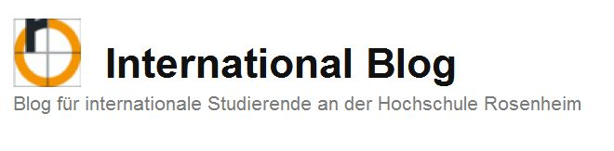
Guide for creating a new blog entry
Category „Incomings“

International Blog: https://international.fh-rosenheim.de/

This guide is intended to help you to publish your feedback in the International Blog of Rosenheim University of Applied Sciences. It takes about ten minutes to create a blog post.
You have to log in before you can start your entry.
You find the login area one the right side of the main page.
Use for the registration the university credentials.
The activation takes about 24 hours by the administrator.
During this time, you can read posts on the blog, but you cannot create new entries.

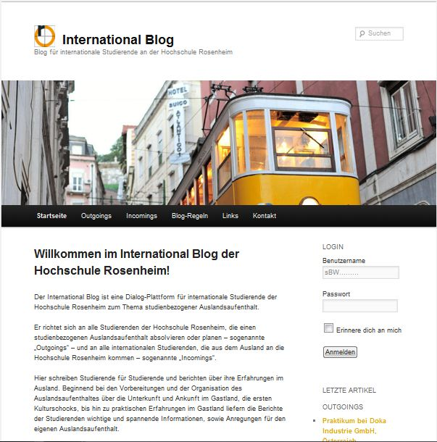
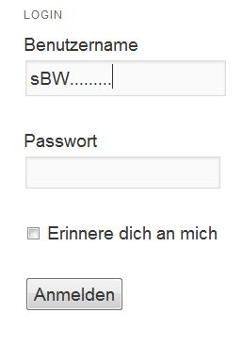
After your account has been successfully activated, you can start with your blog entry. Sign up as described in the picture above with your university username and password.
Under the menu point “Incomings“ in the International Blog you can download the feedback questionnaire, see also https://international.fh-rosenheim.de/incomings/.
As next step you need a photo of yourself (preferably, the photo should be taken on the campus of Rosenheim University). You will need the questionnaire and the photo later for your blog entry.
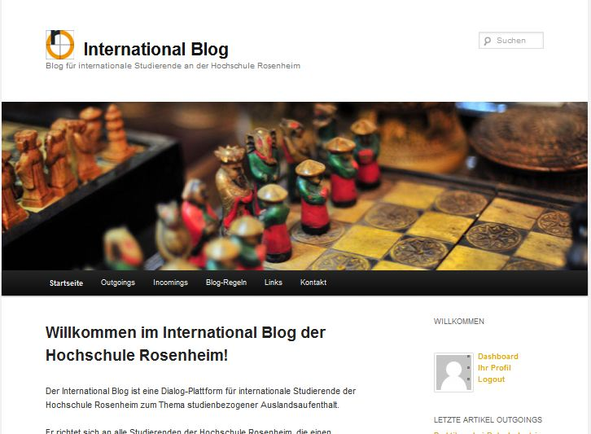
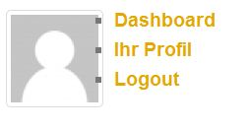
You see if your account is already unlocked if the menu appears on the right side of the page (see above). Go to the menu item “Dashboard”.
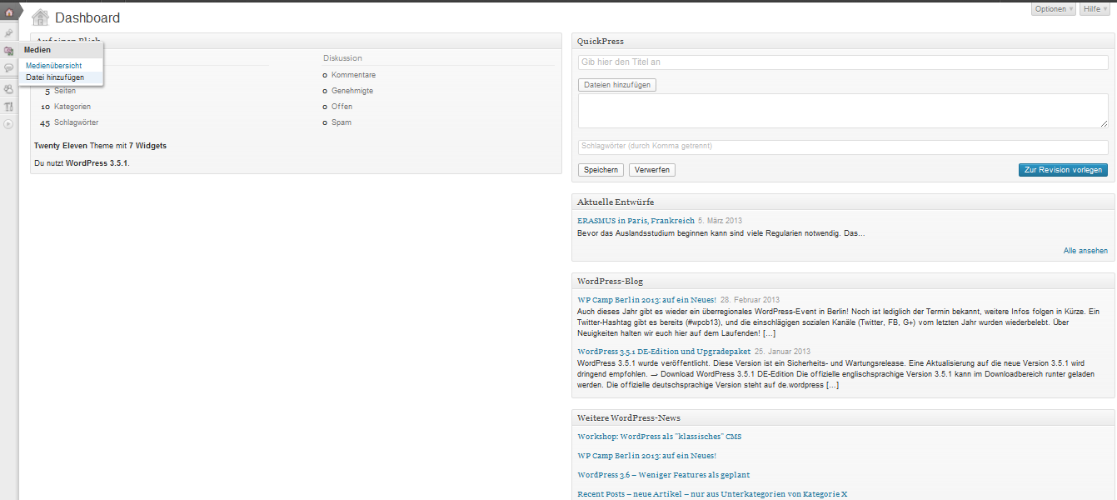
In the Dashboard, click on the menu item “Media“ „Datei hinzufügen“ (“Add file”).
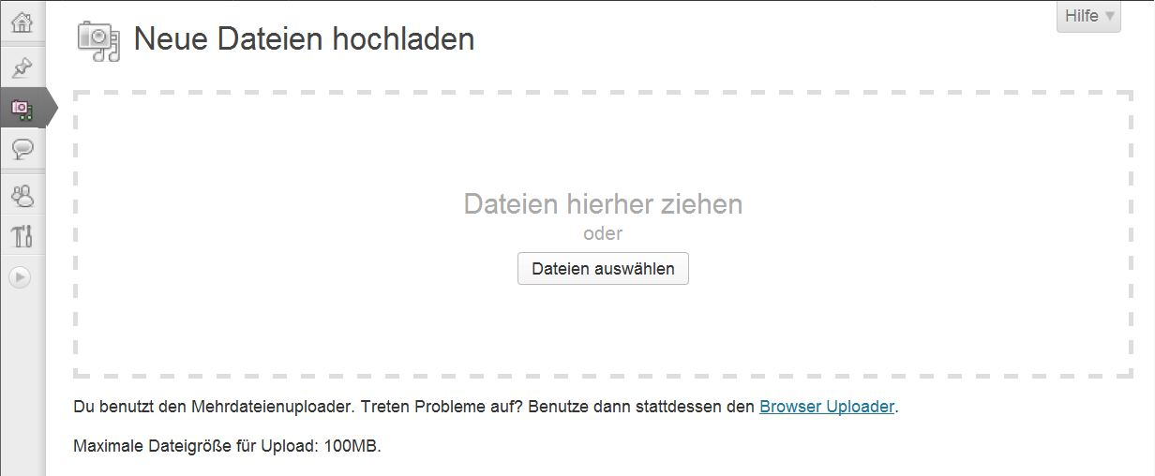
Add both files - your feedback questionnaire and your photo - to the media library. Please make sure that the questionnaire and your picture are named as follows:
name_first name_Incomings
Example: Mustermann_Max_Incomings
After you have uploaded the files from your computer, you can begin with the blog entry. For this purpose click on the second point “Beiträge” (“Posts”) in the Dashboard and then on “Erstellen” (“Create”).
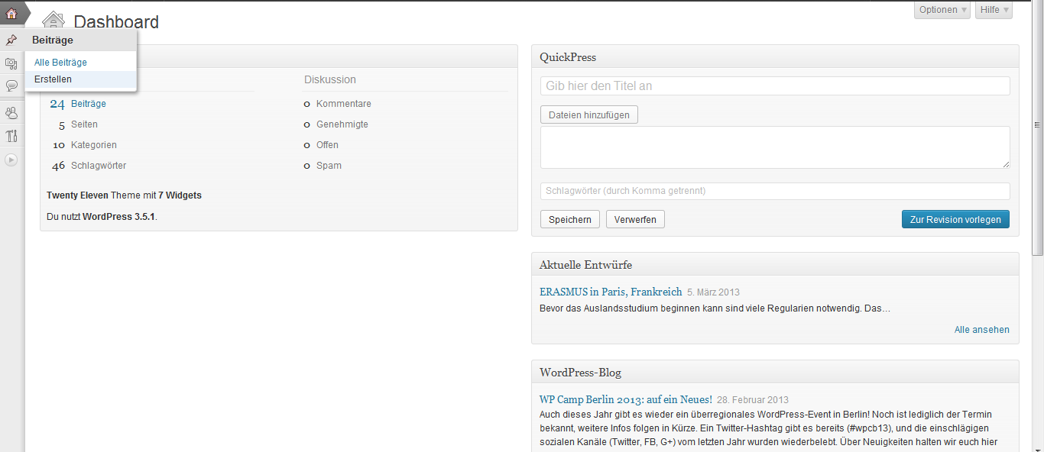
The headline (1) can be formulated as follows:
- Feedback from an ERASMUS Student
- Feedback from an International Student
- 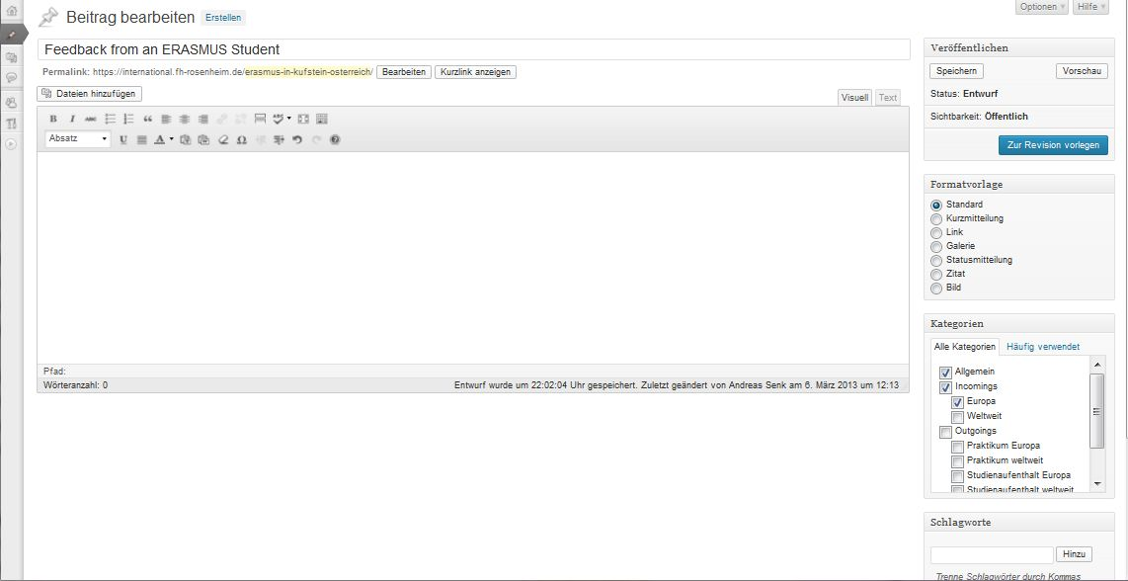
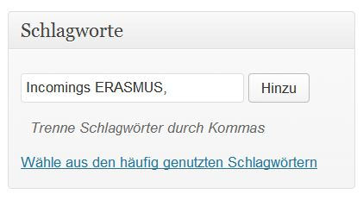
(1)
(4)
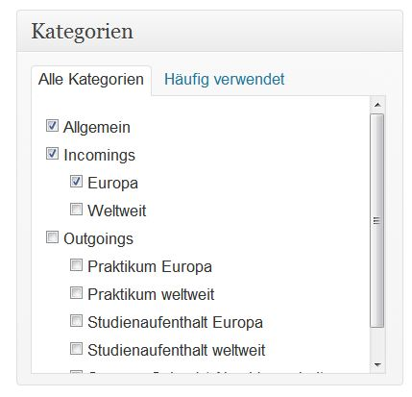
(3)
(2)
Copy your short feedback from your questionnaire to the text field (2).
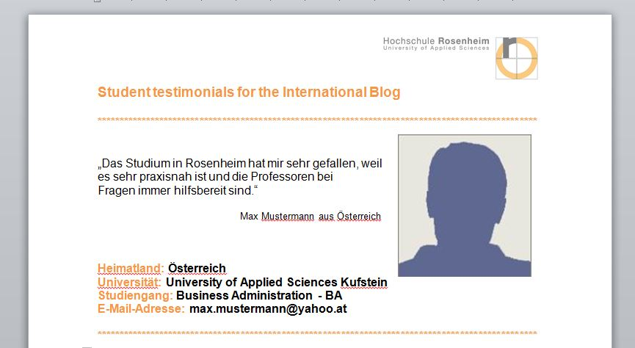
To make sure that your entry can be easily found you need to provide some details about your stay in the menu “Kategorien” (“Categories”).
The following categories can be chosen:
- Incomings (should always be selected)
- Europa
- Weltweit
Additionally, tags (“Schlagwörter“) have to defined, for example:
- Incomings ERASMUS or Incomings International
As the next step you have to insert your photo and questionnaire into the blog entry.
To do so, please go with the cursor to the beginning of your entry and click on “Dateien hinzufügen” (“Add Data”). Afterwards go to the menu point “Media library”, where you can see all uploaded photos. Choose your picture from the media library. Please take care that the setting “Dateianhang mit dem Link zur Medien-Datei” is enabled. The setting option can be found at the bottom on the right (see below). If all settings have been done, click on the button “In den Beitrag einfügen” (“Add the post”) in order to import your picture into your post.
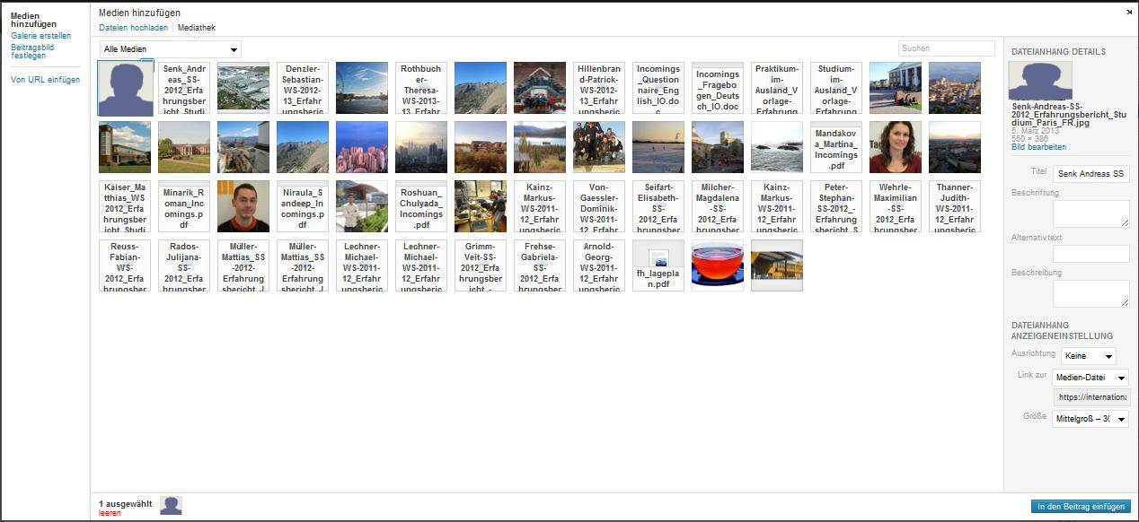
To make sure that your photo is displayed on the left side and the text on the right, you have to click on the inserted photo. Now two icons are displayed. Choose the left one.
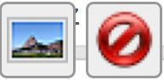
In the following menu screen you can adjust the size of the photo and the text alignment. Select the alignment “links“ (“left“) so that the text begins directly beside the photo.
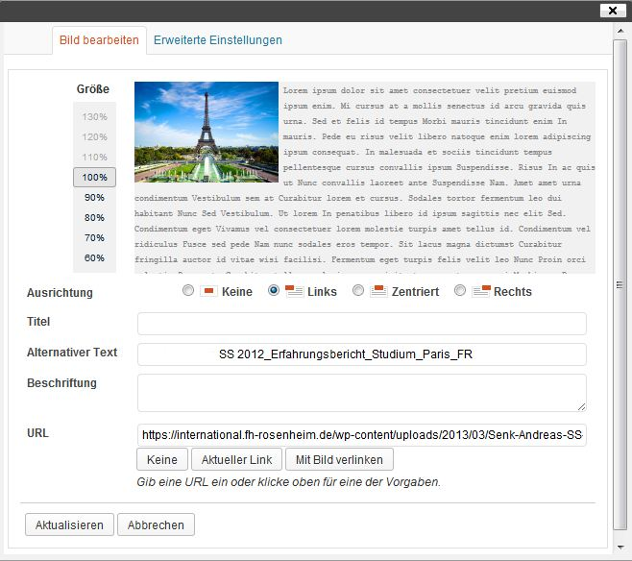
If you have made all settings click the button “Aktualisieren” (“Update”) to come back to the text field.
Your photo should now be on the left side and your quote on the right side. Please add below your quote the following sentence in bold lettering:
“Download International Student Feedback:“
Go with the cursor to the next line and click again “Dateien hinzufügen“ (“Add Files“) and search for your questionnaire in the media library. Please make sure that the setting “Link zur Medien-Datei“ (“Link to the media file“) is selected again.
The questionnaire should now be displayed as a link in your blog entry.
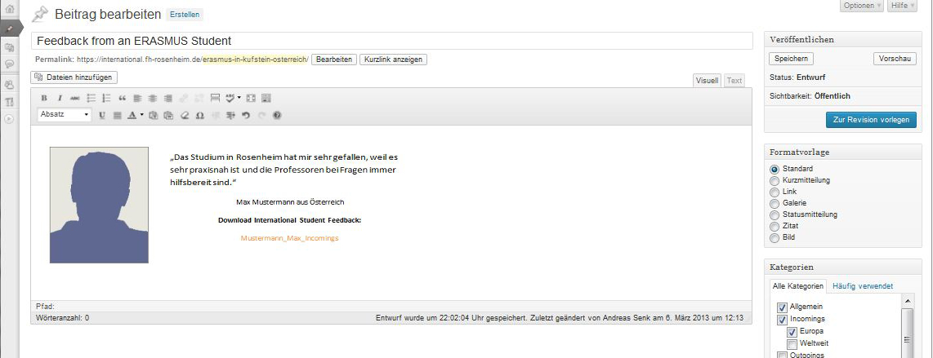
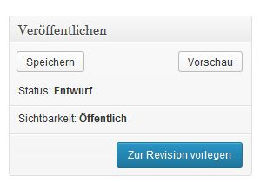
Beside the text window you can save your post and can see a preview (“Vorschau”). When all information has been supplied and the display of the entry is free of mistakes, click the button “Zur Revison vorlegen” (“Submit to Inspection”). The post will be activated later by the administrator. Many thanks for your post!

